##### KELLY CALECHE

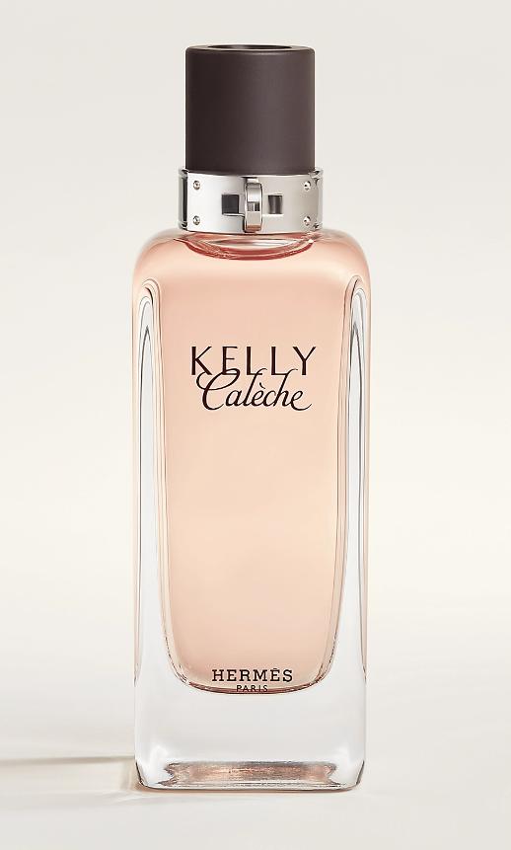

Kelly Calèche: written by Jean-Claude Ellena as an interpretation of the memory of a visit to the Hermès skin warehouse, this expression of a light leather is at once feminine and joyous. Kelly Calèche gives a nod to two emblematic House references, translating the tactile, olfactory emotions of the perfumer while evoking a skin-deep leather, tanned by caresses and embroidered with fresh petals.

The note that spreads throughout the fragrance and stealthily dominates is a note of fine leather. The fragrance is considered to be youthful because of the fruity and floral traces which gently caress. It is aimed at girls 20-25 years of age, young ladies with already formed taste and style, which can wear Kelly Caleche with joy. It comes as 50ml (1.7 oz.fl.) and 100ml (3.4 oz.fl.) EDT. The bottle is designed by Philippe Mouquet.

The house of Hermes presents a new and very interesting bottle for Kelly Caleche Pure Perfume, perfume extract of Kelly Caleche, in Autumn 2008. This innovative and very charming lock hides notes of sensual and gentle perfume dedicated to Kelly bag with discrete and elegant leather aromas. It is one of the products which made the house of Hermes highly respectable. Kelly Caleche, work of perfumer Jean-Claude Ellena, attracts and seduces with its romantic mood and a fresh, luxurious trail of the composition. The small chain that hides this perfume inside its body can be hidden in your hand or purse and kept just for you.